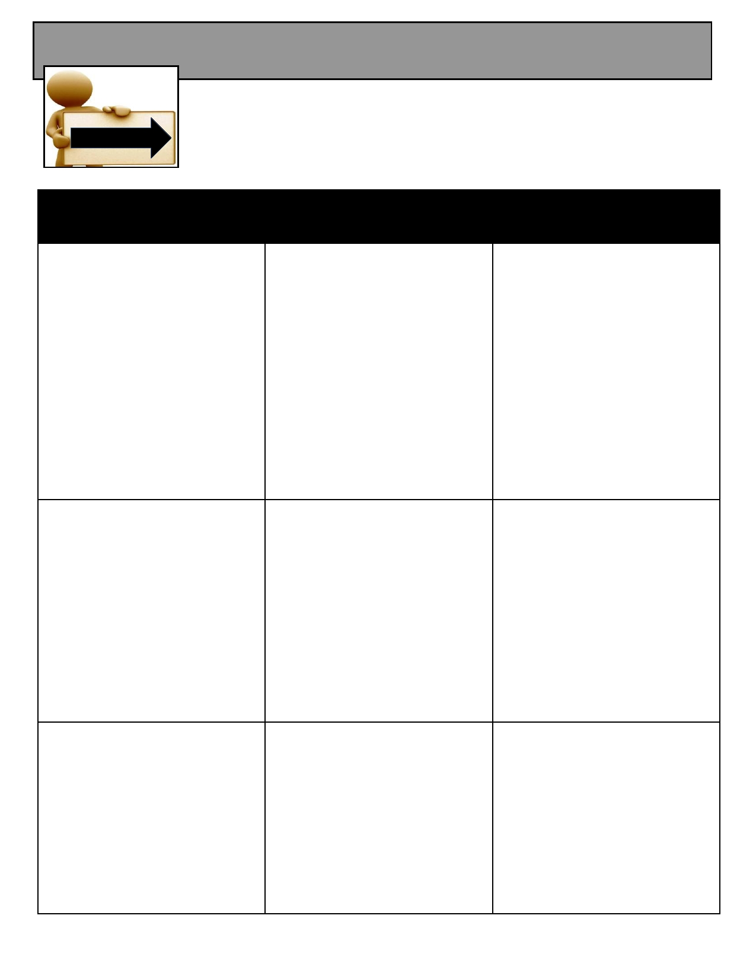
Bakersfield College - CAS Descriptions Spring 2014
C.A.S.
Critical Academic
Skills Workshop CAS: Critical Academic Skills Workshops
FIND THE CAS WORKSHOPS YOU NEED!
Each workshop offers active learning activities. Workshops begin promptly! CAS schedule is available on InsideBC under the Student tab.

Study and Life Skills

Be a Successful Student

This workshop will help students
assimilate on the college
campus. Topics discussed will
be the differences between college vs. high school and
navigating the college system.
They will also learn why it is
important to know the campus
culture, expectations, also pitfalls that may arise, and where to go for assistance.

Maximize Memory

In this workshop, students will
learn to identify and
demonstrate memory techniques, including
concentration, classification,
repetition, association, and
mnemonic devices. They will
learn 12 principles to help
increase memory skills!

Getting Organized

This workshop will help a
student plan ahead for quizzes,
tests, midterms, and finals by
creating their own personalized
academic calendar with
important dates for each course,
as well as important dates on the BC campus.

Test Taking Tips

Upon completion, attendees
should understand and be able to apply the PIRATES strategy
and its subsets to a real test
situation. PIRATES: Prepare to
succeed; Inspect the
instructions; Read, Remember,
Reduce; Answer or Abandon;
Turn Back; Estimate; Survey

Successful Note Taking Skills

Students will realize the importance of sharpening their listening skills and learn to use
standard methods of note taking
including punctuation,
abbreviations, margins, and
effective use of the CORNELL SYSTEM.

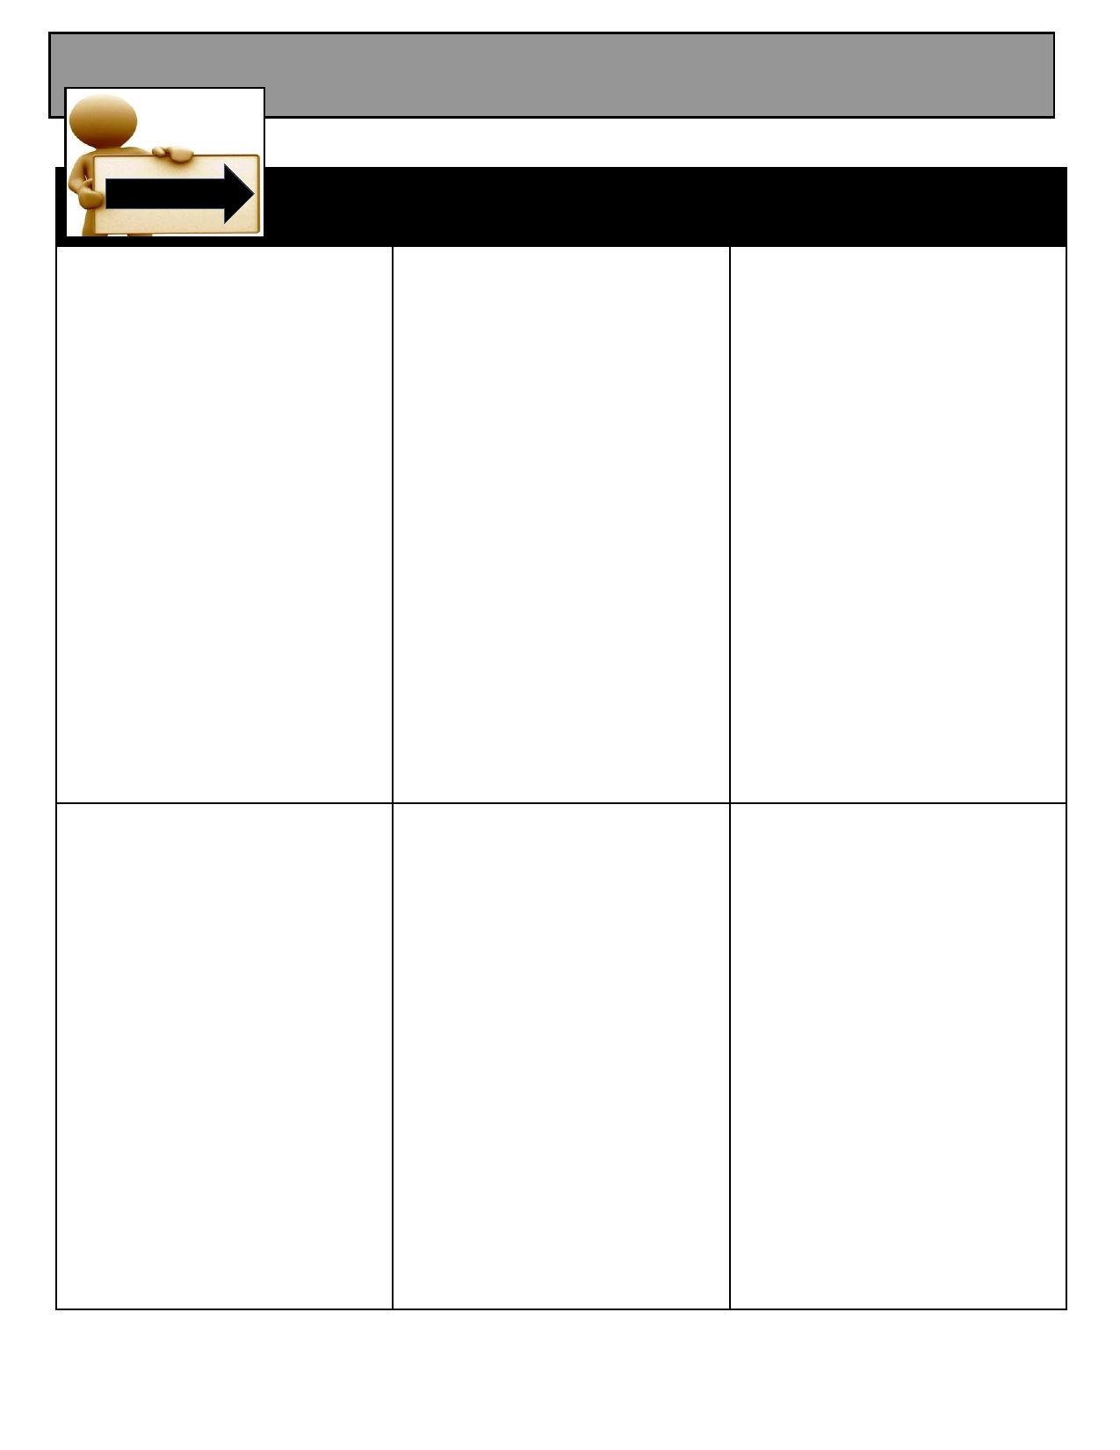
Bakersfield College - CAS Descriptions Spring 2014
C.A.S.
Critical Academic

Skills Workshop CAS: Critical Academic Skills Workshops
English Skills

Preventing Plagiarism

The plagiarism workshop
tackles basic plagiarism
problems through discussion
and use of examples. After
discussing and defining various kinds of plagiarism, the students will examine sample
paraphrases and quotes,
comparing them to the original
passages to determine accuracy
and detect any plagiarism problems in the passages.
Finally, students will work in
groups to practice paraphrasing a passage of writing.

How to Paraphrase
Students will refine their ability to reconstruct ideas from text in their own words for a number of purposes: 1) to demonstrate understanding of a particular passage, 2) to produce a coherent summary, and 3) to avoid the potential for plagiarism.

How to Summarize
Students are first taught the SQ3R Method for reading a passage. Next, they are shown how to take notes on the same passage and, finally, how to transform the main ideas and major details of their notes into a well-developed summary of the material. Extensive modeling and opportunities to practice are provided throughout the workshop.
Fragments and Run-ons

Students will learn to identify a
fragment and acquire ways to fix the fragment to make it an
independent sentence using a variety of strategies. Students will also learn to identify run-on sentences (fused and
comma splice) and develop ways to repair the run-on using different approaches.
.

