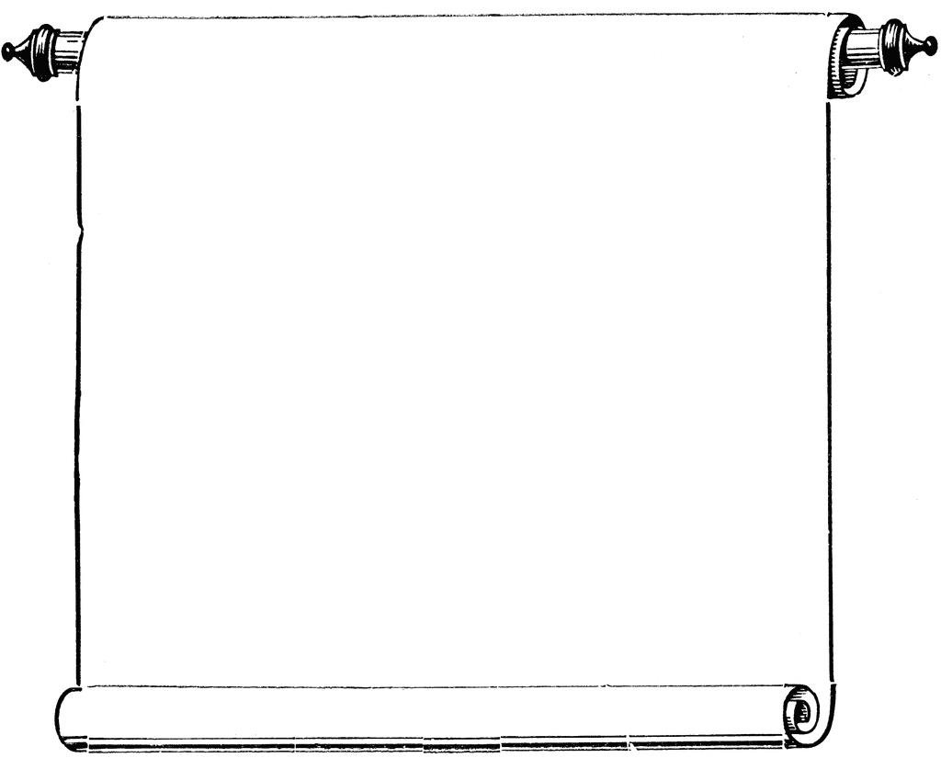

**Last CAS Workshop for this Semester!**

**CAS Workshops**

Week of December 1-4, 2014

**December 1**

1:30-2:30

Organize!, Library 147

E. Miller

**December 2**

1:30-2:30

Test Taking Tips, Library 147

C. Schaefer

**December 3**

2:00-3:00

Organize!, Library 147

E. Miller

**December 4**

NO WORKSHOPS