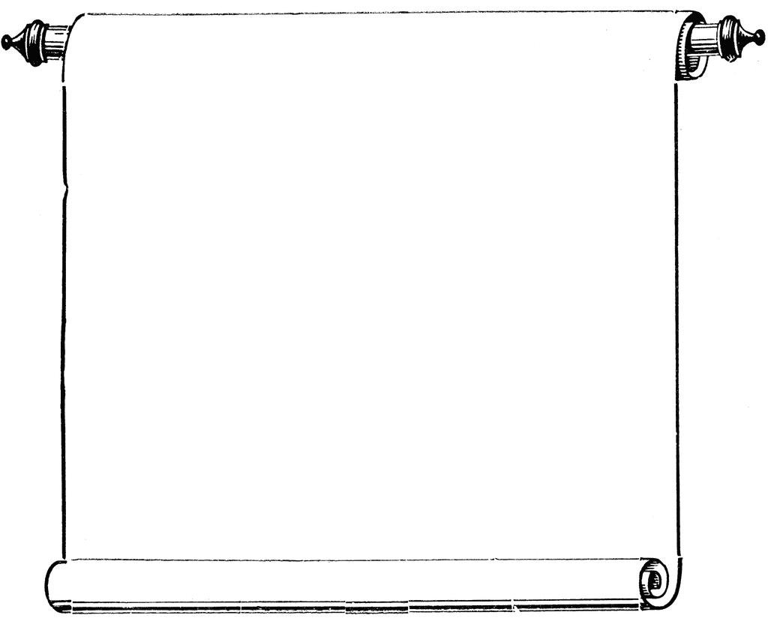

**CAS Workshops**

Week of November 10-13, 2014

**November 10**

1:30-2:30

Fighting Fragments, Library 147

A. Townsend

**November 11**

VETERAN’S DAY—No workshops!

**November 12**

1:30-2:30

College Survival Skills,Library 147

C. Schaefer

3:00-4:00

Writing a Strong Thesis Statement, Library 147

S. Abbassi

**November 13**

2:30-3:30

Learn for Life, Library 147

R. Vickrey

4:00-5:00

Persist/Be Focused, Library 147

A. Henderson