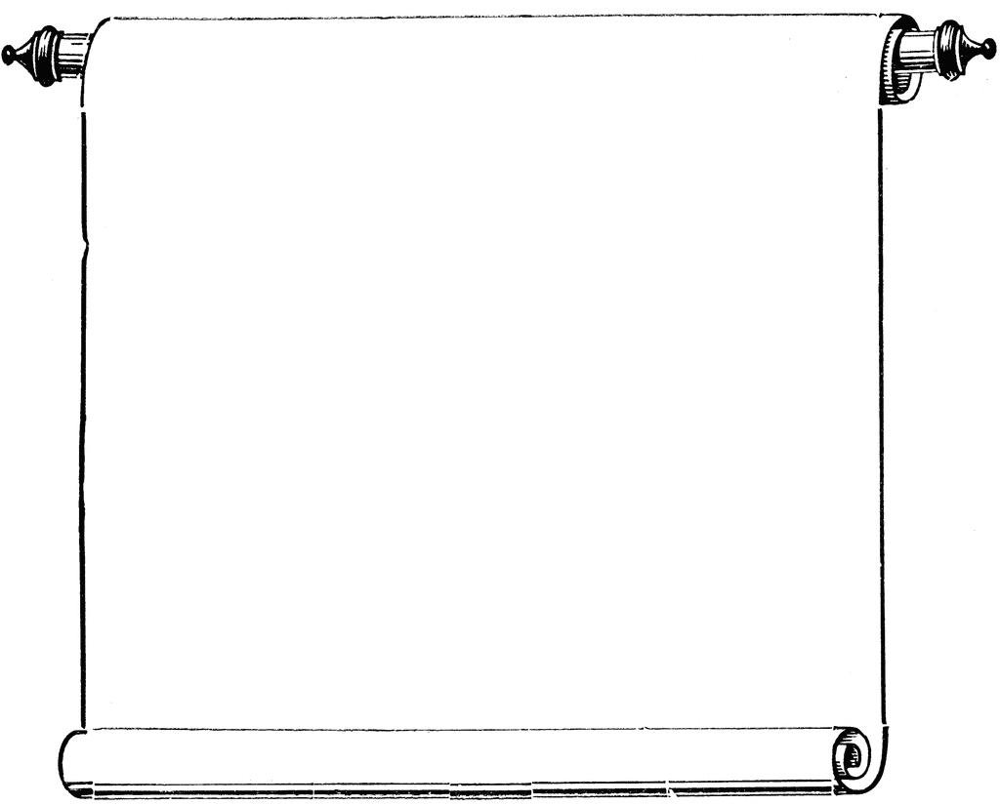

**CAS Workshops**

Week of November 17-20, 2014

**November 17**

12:00-1:00

The Art of Writing Summaries, Library 129 (SI Area)

R. Lango

**November 18**

12:30-1:30

Maximizing Memory, Collins Conference Center

C. Schaefer

2:00-3:00

Striving for Excellence/Emphasizing Integrity

Collins Conference Center

V. Robinson

**November 19**

11:30-12:30

Stay Involved,Collins Conference Center

J. Davies

1:00-2:00

Preventing Plagiarism, Collins Conference Center

T. Meier

**November 20**

2:00-3:00

Be Focused/Innovate, Collins Conference Center

M. Duarte-Smith