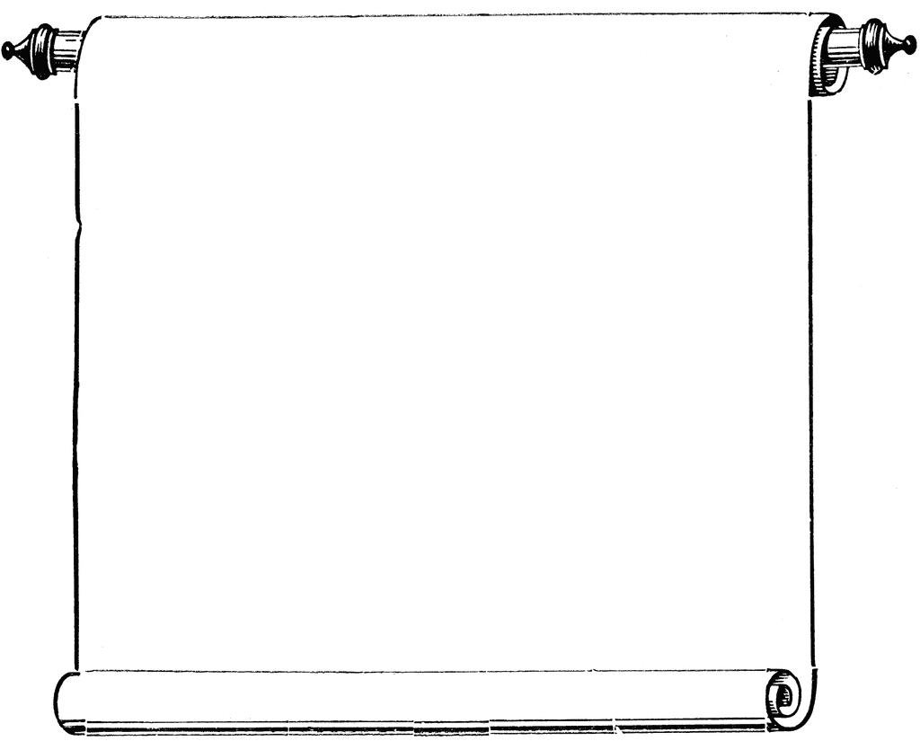

**CAS Workshops**

Week of November 3-6, 2014

**November 3**

1:30-2:30

The Art of Writing Summaries, Library 147

R. Lango

**November 4**

1:30-2:30

Maximizing Memory, **Library 147** (note: this is a room change)

C. Schaefer

**November 5**

2:00-3:00

Preventing Plagiarism, **Library 147** (note: this is a room change)

T. Meier

**November 6**

11:10-12:00

Organize!, Collins Conference Center

E. Miller

3:00-4:00

Persist/Be Focused, Collins Conference Center

S. Rahman