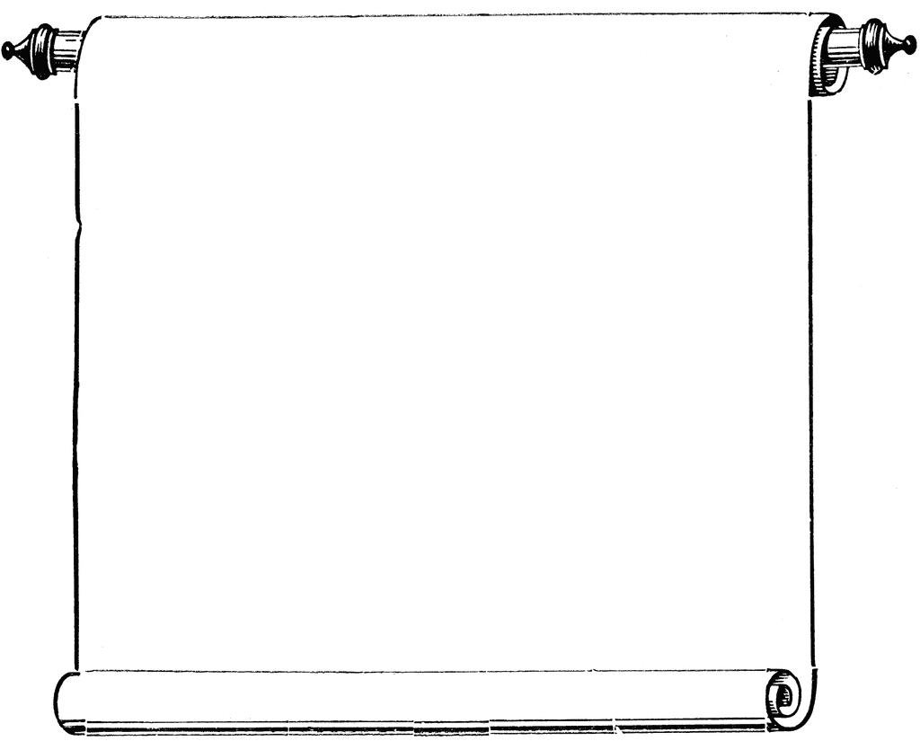

**CAS Workshops**

Week of October 27-30, 2014

**October 27**

1:30-2:30

Writing a Strong Thesis Statement, Library 147

S. Abbassi

2:30-3:30

The Art of Writing Summaries, Library 147

R. Lango

**October 28**

1:30-2:30

Test Taking Tips, Library 147

C. Schaefer

**October 29**

2:30-3:30

Preventing Plagiarism, Library 147

T. Meier

**October 30**

2:00-3:00

Innovate, Library 147

J. Davies